|  |  |
| --- | --- |
| BlueT_nobackgroundcmyk_sml | logo |
|  |  |
|  |  |

**Path Optimizer User Guide**

|  |  |
| --- | --- |
| Document No. : | *1* |
| Date: | 19-Nov-18 |
| Author: | Reshmi Raveendran |

Table of Contents

[1 Purpose 3](#_Toc530405164)

[2 Application Overview 3](#_Toc530405165)

[3 Accessing Path Optimizer 3](#_Toc530405166)

[4 Features 3](#_Toc530405167)

# 

# **Purpose**

This document is intended to assist the users in getting started with Path Optimizer and explains the different features and components available for user consumption.

# **Application Overview**

Users can access the application to find shortest possible route that visits each city and return to the origin city.

# **Accessing Path Optimizer**

Path Optimizer GUI can be access through the below link.

URL: http://hostname:8778/pathOptimizer

# **Features**

User will be prompted to enter number of cities and adjacency matrix of the graph representing location of cities.

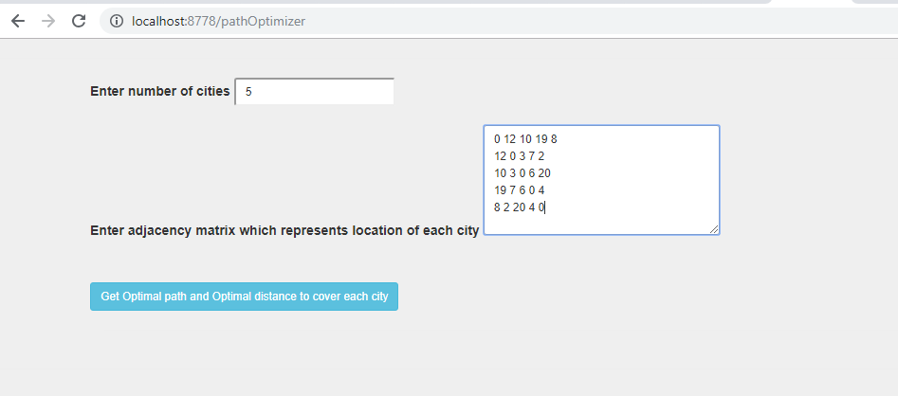

Path Optimizer will compute the optimal solution for the given problem and displays the same in GUI

